**Shashwat Tripathi**

**D10A 58**

**BATCH: C**

**PYTHON LAB**

**Exp No: 5**

**AIM:** 1. Demonstrate a python code to print try, except and finally block statements.

2. Demonstrate a python code to Compile time errors.

3. Demonstrate a python code to Run time errors.

**CODE:**

1. **Try,Except,Finally**

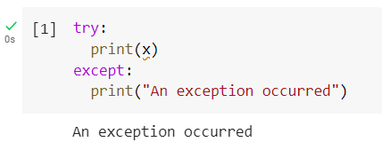

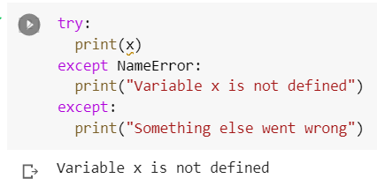

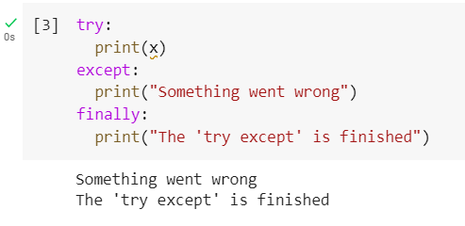

1. **Compile Time Errors**

Syntax Errors-

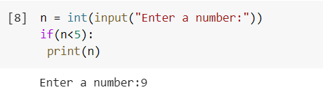

Semantics Errors-

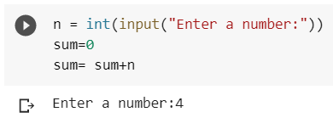

1. **Runtime Errors**

Logical error-

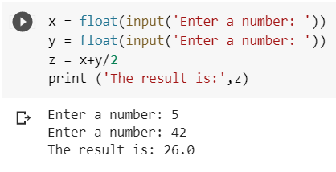

Index error-

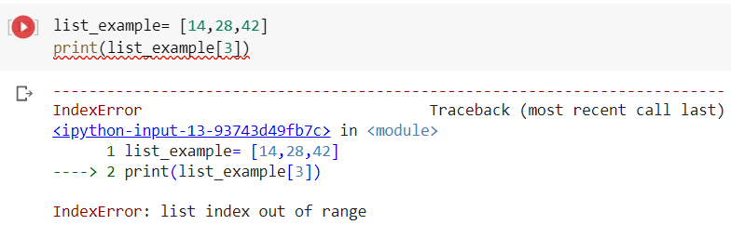

Module error-

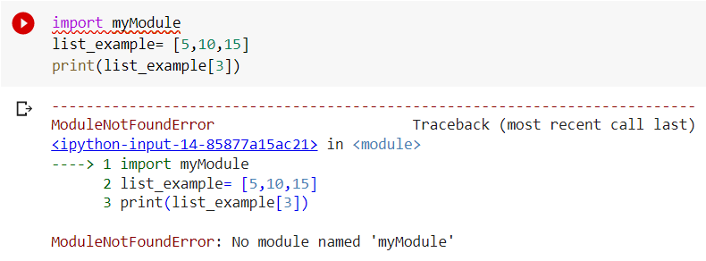

Value error-

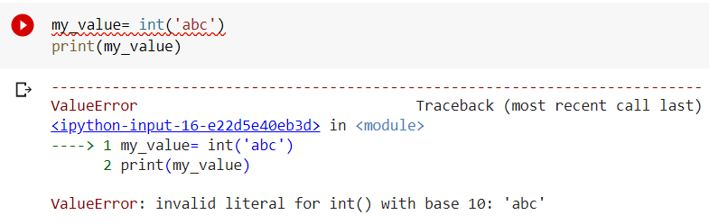

Divide by zero-

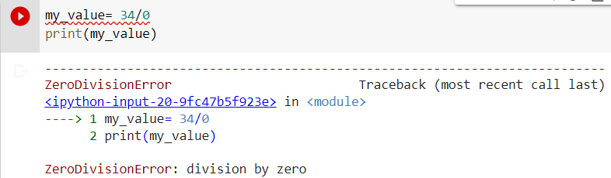

Name error-

